Course Title: Social Immersive Learning
Course Code: 24UC0021
Name: L.Ishitha
Roll No: 2420030041
Section: 10

Title of the Topic:
Front-End Arena

Introduction:
Front-End Arena is an engaging and creative event organized as part of the Front-End Development Fundamentals (FEDF) class. It provides students with an opportunity to showcase their technical proficiency and artistic sense by designing visually captivating and functionally efficient web interfaces. The event emphasizes the integration of design aesthetics with coding logic, allowing participants to explore technologies such as HTML, CSS, and JavaScript to build responsive, interactive, and user-friendly websites or web applications.
This platform not only celebrates creativity but also encourages students to think critically about user experience, accessibility, and interface design while implementing their innovative ideas.

About the Event:
The Front-End Arena serves as both a competition and a hands-on learning opportunity for students passionate about web development. Participants are challenged to conceptualize, design, and develop web projects—ranging from personal portfolios and mini web applications to thematic webpages—that reflect their creativity and technical skill.
The event focuses on:
- Applying modern design principles such as color harmony, layout composition, and typography.
- Using responsive design techniques to ensure cross-device compatibility.
- Enhancing user interactivity through animations, transitions, and JavaScript functionalities.
- Promoting teamwork, collaboration, and peer learning among participants.
Students also receive valuable feedback from mentors and peers, helping them refine their projects and improve their front-end development abilities. Through this event, participants gain a deeper understanding of UI/UX design and modern web technologies, preparing them for real-world development scenarios.

Key Learnings:
- Practical application of front-end technologies: HTML, CSS, and JavaScript.
- Improved understanding of responsive design and UI/UX principles.
- Development of creativity and problem-solving in web design.
- Experience in project presentation and peer evaluation.
- Exposure to industry-relevant skills in modern web development.
- 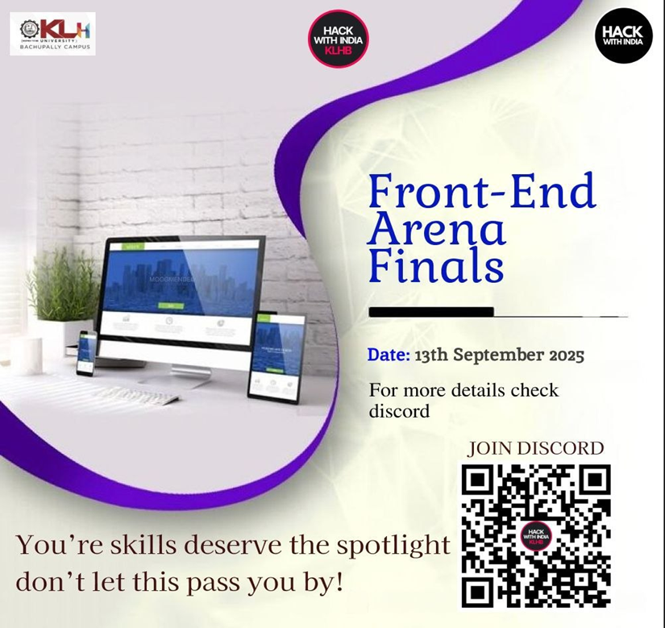

Conclusion:
The Front-End Arena was a highly enriching experience that blended creativity with technology. It allowed participants to transform ideas into functional digital experiences while deepening their understanding of web development. The event inspired innovation, encouraged collaboration, and strengthened participants’ confidence in building visually appealing and user-centered web solutions. Overall, it served as a stepping stone toward mastering front-end development and pursuing excellence in modern web design.

